Section 1: Design and draw UML class diagram to represent an airline reservation system. The system enables the customer to search for airline flight on a specified date and choose a flight based on some details like availability. The customer can reserve a flight or cancel his reservation. The system displays all the flight details such as flight number,name,price and duration of journey.

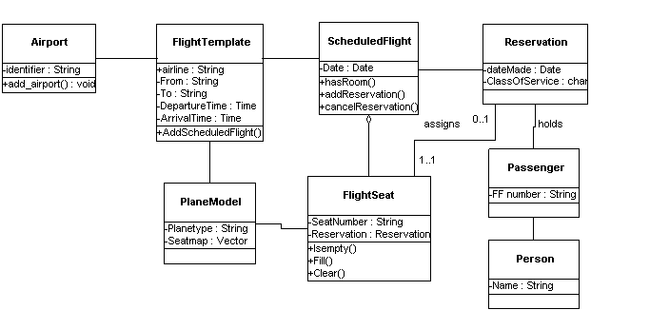

Section 2: Design and draw UML class diagram with attributes,behaviour, and class relationships for the following scenario.

In a university there are various departments. A department has a name and is associated to classrooms and offices. An employee working at the university has a unique Id and can be a professor or an instructot. A professor can be a full professor,associate professor,or assistant professor and he/she belongs to a department in the university. Offices and classrooms also have unique IDs and classrooms have fixed number of seats. Also, every employee is assigned an office.



Section 3:

